## **LD-Net-Lightweight-Dehazing-Network**

## **A PROJECT REPORT**

Submitted in partial fulfillment of the requirement for the award of the degree

of

**BACHELOR OF TECHNOLOGY**

in

**COMPUTER SCIENCE AND ENGINEERING**

**SUBMITTED BY**

Ashutosh Jha (21103029)

Amrendra Kumar (21103013)

Arshia Sareen (21103027)

Ayush Kumar Sehgal (21103033)

Sukrit Sharma (21103146)

Under the supervision of

**Dr. K.P. Sharma**

**Assistant Professor**



**Department of Computer Science and Engineering**

**Dr. B. R. Ambedkar National Institute of Technology Jalandhar**

**-144008, Punjab (India)**

**May 2024**

**Dr. B. R. Ambedkar National Institute of Technology Jalandhar**

**CANDIDATES’ DECLARATION**

We hereby declare that the work presented in this project, titled " LD-Net-Lightweight-Dehazing-Network," is entirely my own and has been completed as part of the requirements for the Bachelor of Technology degree in Computer Science and Engineering at Dr. B R Ambedkar National Institute of Technology, Jalandhar. All sources used for information, data, or inspiration have been appropriately cited and referenced. I affirm that there has been no plagiarism or unauthorized use of others' work in this project.

Furthermore, I acknowledge the guidance and support provided by Dr. K.P. Sharma, my professor, throughout the duration of this project. Their expertise and mentorship have been invaluable in shaping the direction and outcomes of this research endeavor. I take full responsibility for the accuracy and integrity of the content presented herein, and I understand the consequences of academic dishonesty.

Date: 31th May, 2024

Submitted by

Ashutosh Jha (21103029)

Amrendra Kumar (21103013)

Arshia Sareen (21103027)

Ayush Kumar Sehgal (21103033)

Sukrit Sharma (21103146)

This is to certify that the statements submitted by the above candidates are accurate and correct to the best of our knowledge and are further recommended for external evaluation.

Dr. K.P. Sharma Supervisor Dr. Rajneesh Rani

Assistant Professor Head and Associate Professor

Deptt. of CSE Deptt. of CSE

**ACKNOWLEDGEMENT**

The realization of any complex scientific endeavor necessitates the collaboration and contributions of a multitude of individuals operating behind the scenes. The LD-Net-Lightweight-Dehazing-Network project was no exception, and our research team was fortunate to receive invaluable guidance and assistance from numerous sources throughout the project's duration. The achievements we have attained are attributable to the extensive support and supervision we received, for which we express our profound gratitude.

First and foremost, we extend our deepest appreciation to our project mentor, Dr. K.P. Sharma, Assistant Professor, whose faith in our hypotheses and timely recommendations were instrumental in shaping the project's trajectory. His steadfast support in resolving the challenges we encountered was indispensable.

We are equally indebted to Dr. Rajneesh Rani, Head of the Department of Computer Science and Engineering, for her direct and indirect contributions, which played a crucial role in facilitating our research endeavors.

Our sincere gratitude also extends to Dr. Aruna Malik, Coordinator Minor Project, for providing us with mentors and the necessary resources to support our work.

We are profoundly grateful for the continuous encouragement and guidance we received from the esteemed faculty of the Department of Computer Science & Engineering. Additionally, we would like to express our sincere appreciation to the laboratory staff for their timely assistance, which was vital to the successful execution of our project.

Thank You.

[Ashutosh,Amrendra,Arshia,Ayush,sukrit]

**ABSTRACT**

Haze, a common atmospheric phenomenon caused by the suspension of tiny particles such as dust, smoke, and other pollutants, significantly degrades the visibility and quality of images. This degradation poses a substantial challenge for various computer vision applications, including object detection, classification, and tracking, which rely on clear and detailed images for accurate performance. Traditional dehazing techniques often employ the atmospheric scattering model to address this issue. This model decomposes a hazy image into its components by estimating the global atmospheric illumination and the transmission coefficients that represent the haze effect. However, these methods can be computationally intensive and may struggle to generalize across diverse natural scenes, limiting their applicability for real-time processing tasks.

This project introduces LD-Net, a lightweight dehazing network Convolutional Autoencoder specifically designed to overcome the limitations of traditional methods. LD-Net is built on a convolutional autoencoder (CAE) architecture, which consists of an encoder-decoder structure. The encoder extracts haze-relevant features from the input image through a series of convolutional layers and pooling operations, producing a compressed latent representation, or bottleneck, of the image. The decoder then reconstructs the dehazed image from this bottleneck using deconvolutional layers and upsampling operations. By avoiding the need for explicit atmospheric scattering models and transmission map estimation, LD-Net significantly reduces computational complexity and enhances processing speed, making it suitable for real-time applications on low-spec hardware.

To validate the effectiveness of LD-Net, we conducted extensive evaluations using several benchmark hazy image datasets. The performance of LD-Net was assessed based on key image quality metrics, including Peak Signal-to-Noise Ratio (PSNR) and Structural Similarity Index Measure (SSIM). These metrics provide a quantitative measure of the quality of the dehazed images compared to the ground truth. The results demonstrated that LD-Net achieves competitive performance, maintaining high image quality while operating at a significantly faster rate compared to existing state-of-the-art methods. This efficiency is crucial for applications that require real-time image processing, such as autonomous driving, intelligent surveillance systems, and real-time video enhancement.

The architecture of LD-Net is designed to be lightweight, ensuring that it is not limited by the computational capabilities of low-spec systems. This broadens its potential applications across various fields where resource constraints are a concern. However, the current version of LD-Net exhibits some limitations, particularly in handling indoor scenes and low-light images. These limitations highlight the importance of training data diversity, as the model was primarily trained on outdoor images. Indoor and low-light environments often have different visual characteristics, which can affect the model’s performance.

Future work will focus on addressing these limitations by incorporating a more diverse range of training data, including images from indoor and low-light conditions. Additionally, exploring alternative loss functions, such as those based on perceptual quality metrics, and experimenting with different network architectures could further enhance LD-Net’s dehazing capabilities. By refining these aspects, LD-Net could achieve even better generalization across various image conditions and improve its robustness and applicability.

In conclusion, LD-Net represents a significant advancement in the field of image dehazing, offering a robust, efficient, and lightweight solution that balances network complexity and image quality. Its ability to deliver high-quality dehazing performance at real-time speeds makes it an attractive option for numerous applications. By addressing its current limitations through targeted improvements, LD-Net has the potential to become a comprehensive dehazing solution adaptable to a wide range of image conditions, thereby significantly advancing the capabilities of real-time image processing systems.

**PLAGIARISM REPORT**

We have checked plagiarism for our Project Report for our project a **Turnitin.** We are thankful to our mentor Dr. K.P. Sharma for guiding us at this. Below is the digital receipt. The Plagiarism is approximately 10%.



**LIST OF FIGURES**

|  |  |  |
| --- | --- | --- |
| **Figure number** | **Description** | **Page number** |
| Figure 2.1  Figure 2.2  Figure 2.3  Figure 2.4  Figure 2.5  Figure 2.6  Figure 2.7  Figure 2.8  Figure 2.9  Figure 2.10  Figure 2.11  Figure 2.12  Figure 2.13  Figure 2.14  Figure 3.1  Figure 3.2  Figure 5.1  Figure 5.2  Figure 5.3  Figure 5.4  Figure 5.5 | Subsets of the Dataset  Samples of the Images in Reside Dataset  Preprocessing of the Image  Encoder Algorithm  Decoder Algorithm  Loss Function and Optimiser Implementation  Optimisation Algorithm Implementation  Calculation of MSE Loss Plot  Calculation of Mean PSNR  Calculation of Mean SSIM  Model Results  Images From the Homepage of the Web App  Dashboard for Uploading Image and Getting Result  Result Samp  UML (Sequential and Interaction) Diagram  Architecture for LD-Net  Plot of MSE Loss Plot  Result of Mean PSNR  Result of Mean SSIM  Before Sending the Image to backend  Final Output | 9  10  10  12  13  14  14  15  15  16  17  18  18  18  19  20  26  26  27  28  29 |

**LIST OF ABBREVIATIONS**

CNNs: Convolutional Neural Networks

CAEs: Convolutional Autoencoders

PSNR: Peak Signal To Noise Ratio

SSIM: Structural Similarity Index Measure

**TABLE OF CONTENTS**

|  | CANDIDATES’ DECLARATION  ACKNOWLEDGEMENT  ABSTRACT  PLAGIARISM REPORT  LIST OF FIGURES  LIST OF ABBREVIATIONS | ii  iii  iv-v  vi  vii  viii |
| --- | --- | --- |
| 1. | INTRODUCTION   * 1. Background of the Problem   2. Problem Statement   3. Benefits in Real Life   4. Literature Survey   5. Motivation   6. Feasibility   7. Research Objectives | 1-2  2-3  3-4  4-5  5-6  6-8  8 |
| 2. | PROPOSED SOLUTION | 5-14 |
| 3. | TECHNOLOGY ANALYSIS   * 1. UML Diagram   2. Tech Stack Analysis | 15  16-20 |
| 4. | ECONOMIC ANALYSIS | 21 |
| 5. | RESULT AND DISCUSSION   * 1. APP Usage Instructions   2. Risk Analysis | 22-25  26 |
| 6. | CONCLUSION | 27 |
| 7. | REFERENCES | 28 |

**CHAPTER 1**

**INTRODUCTION**

### **1.1 Background of the Problem**

Haze, a natural atmospheric phenomenon caused by the scattering and absorption of light by particles and droplets suspended in the air, poses significant challenges in various fields, particularly in computer vision and image processing. When haze occurs, it reduces the visibility of scenes captured in images, leading to degraded image quality and hindering the performance of computer vision algorithms.

The problem of haze degradation in images has been a longstanding issue in computer vision research. Traditional methods for haze removal often rely on physical models of atmospheric scattering, which describe the interaction of light with particles and gases in the atmosphere. These models decompose a hazy image into its constituent components, including the haze-free scene radiance, atmospheric light, and transmission matrix representing the attenuation caused by haze.

However, despite their theoretical foundation, these traditional methods have several limitations. One major challenge is accurately estimating the parameters of the atmospheric scattering model from hazy images, which can be computationally expensive and prone to errors. Additionally, these methods may struggle to capture the complex variations between clear and hazy images, especially in diverse natural scenes with different lighting and atmospheric conditions.

As computer vision applications continue to advance, the need for effective and efficient solutions for haze removal becomes increasingly critical. Improved visibility in images not only enhances the performance of object detection, recognition, and tracking algorithms but also has practical implications in domains such as autonomous driving, surveillance, aerial photography, and consumer electronics.

In response to these challenges, researchers have explored alternative approaches to haze removal, including deep learning-based methods. These methods leverage the power of convolutional neural networks (CNNs) to learn complex mappings between hazy and clear images directly from data, bypassing the need for explicit modeling of the atmospheric scattering process.

The development of lightweight and computationally efficient dehazing networks has become a focus of research, aiming to deploy these methods in real-time applications with limited computational resources. By leveraging techniques such as convolutional autoencoders (CAEs) and encoder-decoder architectures, researchers seek to design models that can effectively remove haze while maintaining high processing speeds and low memory requirements.

### **1.2 Problem Statement**

The problem at hand revolves around the degradation of image quality caused by haze, a natural atmospheric phenomenon characterized by the scattering and absorption of light particles in the air. Haze significantly reduces the visibility of scenes captured in images, leading to blurred and low-contrast visuals that impede the performance of computer vision algorithms.

Traditional methods for haze removal often rely on mathematical models of atmospheric scattering to decompose hazy images into their constituent components, such as haze-free scene radiance and atmospheric light. However, these methods face several challenges:

1. **Complexity of Atmospheric Scattering:** Estimating the parameters of the atmospheric scattering model from hazy images can be computationally expensive and prone to errors. The relationship between clear and hazy images is highly complex and may not be accurately captured by a single mathematical equation.
2. **Limited Generalizability:** Atmospheric scattering models may struggle to generalize across diverse natural scenes with varying lighting and atmospheric conditions. Models derived from specific types of haze may not perform well on images with different characteristics.
3. **Inefficiency of Traditional Approaches:** Traditional dehazing methods may not be suitable for real-time applications due to their computational complexity and memory requirements. As computer vision tasks increasingly demand real-time processing, there is a growing need for lightweight and efficient dehazing solutions.

Given these challenges, the problem statement entails developing effective and efficient methods for removing haze from images. The goal is to enhance image quality by restoring visibility and clarity while minimizing computational overhead. This involves:

* Exploring alternative approaches to haze removal, such as deep learning-based methods, that can learn complex mappings between hazy and clear images directly from data.
* Designing lightweight and computationally efficient dehazing networks that can be deployed in real-time applications with limited computational resources.
* Evaluating the performance of dehazing methods using objective image quality metrics such as Peak Signal-to-Noise Ratio (PSNR) and Structural Similarity Index Measure (SSIM) to ensure their effectiveness in improving image visibility and clarity.

Addressing the problem statement requires a multidisciplinary approach that combines insights from computer vision, machine learning, and image processing. By developing innovative solutions to remove haze from images, researchers aim to enhance the performance of computer vision algorithms across various applications, from autonomous driving and surveillance to remote sensing and consumer electronics.

### **1.3 Benefits in Real Life**

Haze removal techniques have significant implications for various real-life applications, offering tangible benefits across multiple domains. Some of the key benefits include:

1. **Enhanced Safety in Transportation**: Improved visibility through haze removal can enhance safety in transportation systems, particularly in scenarios such as autonomous driving and aviation. For example, autonomous vehicles equipped with advanced vision systems rely on clear images to accurately detect obstacles, pedestrians, and road signs. By removing haze from captured images in real-time, these systems can make more informed decisions, reducing the risk of accidents and improving overall road safety.
2. **Enhanced Surveillance and Security**: Haze often obstructs the view of surveillance cameras, compromising their effectiveness in monitoring and detecting security threats. By employing haze removal techniques, surveillance systems can enhance image clarity, enabling better identification of objects and individuals even in challenging weather conditions. This is particularly critical in areas such as border security, where maintaining clear visibility is essential for detecting unauthorized crossings and suspicious activities.
3. **Improved Environmental Monitoring**: In environmental monitoring applications, such as wildfire detection and air quality assessment, haze can distort the accuracy of remote sensing data collected from satellite imagery or ground-based sensors. By removing haze from these images, scientists and environmental agencies can obtain clearer and more accurate information about environmental conditions, allowing for better monitoring of natural disasters, pollution levels, and ecosystem health.
4. **Enhanced Visual Communication**: In fields such as photography, cinematography, and media production, haze removal techniques can enhance the visual quality of images and videos, resulting in more captivating and immersive content. By eliminating haze-induced blurriness and enhancing contrast, photographers and filmmakers can create visually stunning imagery that resonates with viewers and communicates their intended message more effectively.
5. **Improved Medical Imaging**: Haze removal techniques can also benefit medical imaging applications, such as X-ray imaging and endoscopy. In endoscopic procedures, for instance, haze caused by fogging or condensation on the lens can obscure the view of internal organs, making diagnosis and treatment more challenging. By employing haze removal techniques in real-time image processing, medical professionals can obtain clearer and more detailed images, facilitating more accurate diagnoses and surgical interventions.

**Real-World Problem Examples**:

* **Autonomous Driving**: Haze can significantly impair the performance of autonomous vehicles by reducing visibility and obstructing sensors. Haze removal techniques can help enhance the safety and reliability of autonomous driving systems by providing clearer images for object detection and navigation.
* **Surveillance Systems**: Surveillance cameras deployed in outdoor environments often encounter haze, which can degrade image quality and compromise security monitoring. Haze removal techniques enable surveillance systems to maintain clear visibility and effectively detect potential security threats.
* **Environmental Monitoring**: Satellite imagery used for environmental monitoring purposes, such as tracking wildfires or assessing air quality, may be affected by haze, leading to inaccurate data analysis and interpretation. Haze removal techniques help improve the accuracy of environmental monitoring by providing clearer images for analysis and decision-making.

By addressing the challenges posed by haze and enhancing image clarity, haze removal techniques contribute to safer, more efficient, and more reliable systems across a wide range of real-life applications.

### **1.4. Literature Survey**

After an extensive review of numerous research papers and GitHub repositories, we concluded that employing a convolutional neural network (CNN) model trained using transfer learning would be the optimal approach for tackling the image dehazing task in this project.

Convolutional Neural Networks (CNNs) have revolutionized computer vision and image processing tasks, such as image dehazing, in recent years. A CNN is a type of neural network specifically designed for image processing, where the input image is passed through multiple layers of convolutional filters, pooling, and activation functions to extract features.

Deep CNNs typically consist of multiple convolutional layers, followed by fully connected layers that perform the specific task, such as dehazing or image enhancement. The number of layers and filters in each layer can be adjusted based on the complexity of the task and the size of the dataset.

Transfer learning has proven to be highly effective in computer vision applications, particularly when dealing with relatively small datasets, which is often the case for specialized tasks like image dehazing. This effectiveness stems from the fact that many computer vision tasks share common features and patterns. For instance, a model trained on a large dataset like ImageNet, which contains images from 1,000 object categories, can learn a wealth of useful features that can be transferred and applied to other computer vision tasks, such as dehazing, object detection, segmentation, and classification.

By leveraging a pre-trained model as a starting point and fine-tuning it on the specific task of image dehazing, transfer learning can significantly improve the accuracy and speed of the model while reducing the amount of training data required.

### **1.5 Motivation**

The motivation behind the proposed LD-Net dehazing network:

1. **Enhancing Visibility**: Haze significantly reduces the visibility of scenes in images, which can hinder various computer vision applications such as object detection, classification, and tracking.
2. **Improving Image Quality**: Hazy conditions degrade image quality by introducing blurriness and lowering contrast, making it challenging for computer vision algorithms to accurately identify features within the image.
3. **Real-world Applications**: Clearing haze from images is crucial for real-world applications such as autonomous driving, surveillance systems, aerial imaging, and satellite imagery analysis, where accurate scene perception is paramount for decision-making.
4. **Addressing Limitations of Traditional Methods**: Traditional dehazing techniques often rely on atmospheric scattering models, which may struggle to capture subtle variations between clear and hazy images and may not generalize well across diverse natural scenes. LD-Net aims to overcome these limitations by adopting a data-driven approach.
5. **Efficiency for Real-time Processing**: LD-Net is designed to be lightweight and computationally efficient, making it suitable for real-time applications where quick processing of hazy images is required, such as in live video streaming or drone-based surveillance.
6. **Potential for Automation**: Automated dehazing techniques like LD-Net can streamline image preprocessing pipelines in various industries, reducing the need for manual intervention and improving overall efficiency.
7. **Enabling Better Decision-making**: Clearing haze from images can lead to more accurate decision-making in critical scenarios such as emergency response, disaster management, and environmental monitoring, where visibility is crucial for assessing situations accurately.
8. **Advancing Research in Computer Vision**: The development of efficient dehazing algorithms like LD-Net contributes to the broader field of computer vision research, fostering innovation and advancing the state-of-the-art in image processing and analysis.

These motivational factors collectively drive the development and adoption of LD-Net and similar dehazing techniques, aiming to improve image quality, enhance visibility, and enable more effective utilization of visual data in various real-world applications.

**1.6. Feasibility   
1. Non-Technical Feasibility:**

* **Market Demand**: LD-Net addresses a growing market demand for image enhancement solutions across industries such as autonomous vehicles, surveillance, satellite imaging, and photography. The need for clear, high-quality images in hazy conditions is universal and drives the demand for effective dehazing techniques.
* **Cost-effectiveness**: LD-Net's lightweight architecture and computational efficiency contribute to its cost-effectiveness. It can run on standard hardware, minimizing the need for specialized infrastructure and reducing operational costs for end-users.
* **User Acceptance**: The user-friendly nature of LD-Net, coupled with its ability to significantly improve image quality, enhances its acceptance among end-users. Whether it's enhancing surveillance footage for security purposes or improving visibility in satellite imagery for environmental monitoring, LD-Net's effectiveness resonates with diverse user groups.
* **Regulatory Compliance**: Ensuring compliance with data privacy and security regulations is crucial for LD-Net's adoption. By adhering to relevant regulatory standards, such as GDPR in Europe or HIPAA in healthcare, LD-Net can build trust and confidence among users regarding data protection and privacy.

**2. Technical Feasibility:**

* **Algorithm Complexity**: LD-Net's convolutional autoencoder architecture is technically feasible to implement using standard deep learning frameworks. Its relatively simple design makes it easy to train and deploy, even for users with limited expertise in deep learning.
* **Data Availability**: The availability of high-quality training data is essential for the success of LD-Net. While datasets for image dehazing exist, ensuring their diversity and adequacy is crucial for training a robust model capable of handling various real-world scenarios.
* **Computational Resources**: LD-Net's modest computational requirements make it accessible to users with varying hardware configurations. It can leverage both CPUs and GPUs for training and inference, providing flexibility and scalability in deployment.

**3. Social Feasibility:**

* **Impact on Society**: LD-Net's ability to enhance visibility in hazy conditions has significant societal implications. It improves safety in transportation by enabling clearer image capture for autonomous vehicles and assists in disaster response by enhancing situational awareness through satellite imagery dehazing.
* **Accessibility**: By offering a lightweight and efficient solution, LD-Net promotes accessibility to image enhancement technology across diverse socio-economic backgrounds. It ensures that advancements in computer vision benefit a wide range of users, regardless of their technical expertise or financial resources.

**4. Economical Feasibility:**

* **Cost Savings**: LD-Net's cost-effective implementation translates into tangible cost savings for businesses and organizations. By reducing the need for manual image enhancement techniques or expensive hardware solutions, LD-Net optimizes resource allocation and improves overall operational efficiency.
* **Market Opportunities**: The widespread applicability of LD-Net across industries creates lucrative market opportunities for developers and vendors. From commercializing dehazing software solutions to offering consulting services for integration and customization, there are various avenues for economic growth and innovation.

**5. Scope:**

* **Future Development**: The scope of LD-Net extends beyond image dehazing to other areas of image enhancement and computer vision. As technology evolves, LD-Net can be adapted and optimized for tasks such as image restoration, denoising, and super-resolution, further expanding its utility and relevance in diverse domains.

In summary, LD-Net demonstrates strong feasibility across non-technical, technical, social, and economic dimensions. Its potential impact on society, coupled with its accessibility and cost-effectiveness, positions LD-Net as a promising solution for addressing the challenges of image dehazing in real-world applications

**1.7 Research Objectives**

The research objectives for LD-Net encompass the development, evaluation, and feasibility assessment of a novel lightweight dehazing network. Firstly, the aim is to construct LD-Net using a convolutional autoencoder (CAE) architecture, focusing on its efficiency and effectiveness in removing haze from images. Subsequently, the research seeks to empirically investigate LD-Net's performance by comparing its outcomes, particularly in terms of image quality metrics like PSNR and SSIM, against original hazy images. This evaluation process involves testing LD-Net on standard benchmark datasets to gauge its applicability in real-time scenarios. Moreover, the feasibility of LD-Net is analyzed across various dimensions, including technical, non-technical, social, and economic aspects. Understanding the practicality and impact of LD-Net in diverse contexts is crucial for assessing its potential adoption and scalability. Finally, the research aims to identify avenues for further refinement and optimization of LD-Net, ensuring its continuous improvement and relevance in addressing image dehazing challenges.

**CHAPTER 2**

**PROPOSED SOLUTION**

The proposed solution for image dehazing involves developing a convolutional autoencoder (CAE) and deploying it through a web application. This approach leverages deep learning techniques to effectively remove haze from images, enhancing their clarity and visibility. The CAE is a specialized type of neural network architecture that is particularly well-suited for image-to-image translation tasks, such as dehazing. The web application will provide an intuitive interface for users to upload hazy images and receive dehazed results, demonstrating the effectiveness of the CAE in real-time.

**#ML Model**

**Convolutional Autoencoder (CAE)**

A convolutional autoencoder is composed of two main parts: an encoder and a decoder. The encoder compresses the input image into a lower-dimensional latent representation, capturing the essential features of the image. The decoder then reconstructs the image from this latent representation, ideally removing the haze in the process.

**Training Process**

The training process involves optimizing the weights of the CAE to minimize the reconstruction error between the hazy input images and their corresponding clear target images. This is typically achieved using a loss function such as Mean Squared Error (MSE), which measures the average squared difference between the predicted and true pixel values. The steps include:

1. 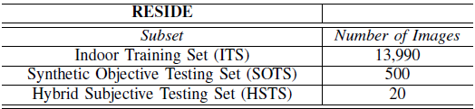**Data Gathering** : Our model is trained on the [Reside Dataset](https://sites.google.com/view/reside-dehaze-datasets/reside-standard)

**Fig 2.1: Subsets of the Dataset**

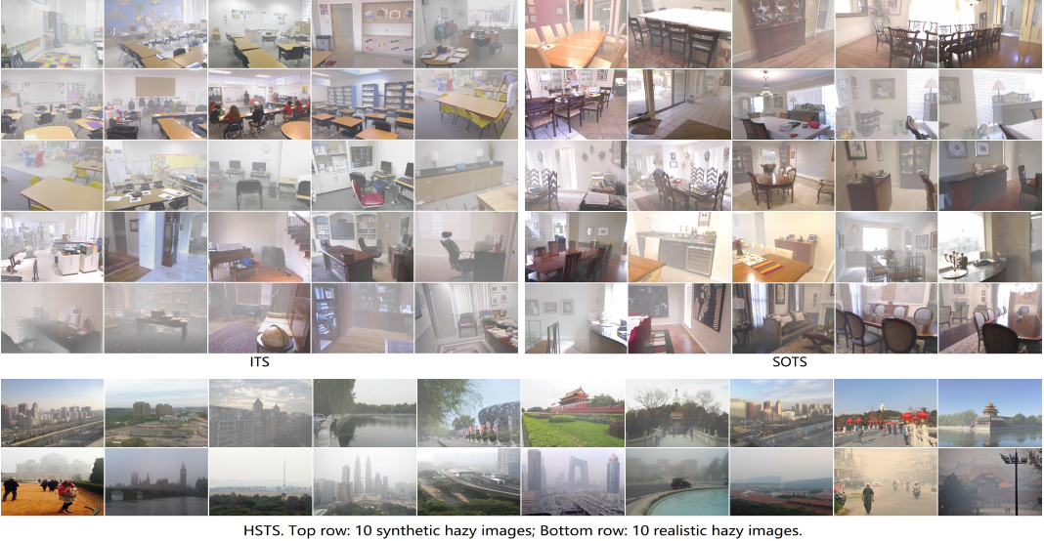

**Fig 2.2: Samples of the Images in Reside Dataset**

1. **Preprocessing**: Resizing and normalizing the images to a consistent format suitable for training.

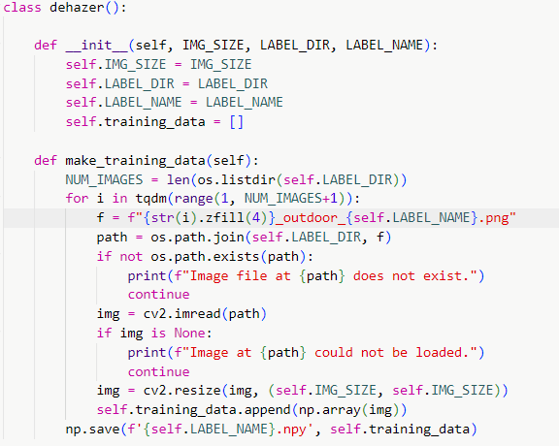

**Fig 2.3: Preprocessing of the Image**

1. **Model Initialization**: Defining the architecture of the CAE with the appropriate layers and parameters.

**Encoder**

The encoder part of the CAE consists of multiple convolutional layers that progressively reduce the spatial dimensions of the input image while increasing the depth (number of feature maps). This compression process helps the network learn a compact representation of the input image. Key components of the encoder include:

* **Convolutional Layers**: These layers apply convolution operations to the input image, extracting local features such as edges, textures, and patterns.
* **ReLU Activation Functions**: Rectified Linear Units (ReLU) introduce non-linearity to the model, enabling it to learn more complex representations.
* **Batch Normalization**: This technique normalizes the output of each convolutional layer, speeding up training and improving the stability of the network.
* **Max Pooling**: Pooling layers downsample the feature maps, reducing their spatial dimensions and retaining the most significant features

**Fig 2.4: Encoder Algorithm**

**Decoder**

The decoder mirrors the encoder structure but in reverse. It takes the compressed latent representation and progressively reconstructs it back to the original image dimensions. Key components of the decoder include:

* **Transposed Convolutional Layers**: These layers perform the opposite operation of convolutional layers, upsampling the feature maps to increase their spatial dimensions.
* **ReLU Activation Functions**: Similar to the encoder, ReLU functions introduce non-linearity in the decoder.
* **Batch Normalization**: Normalizes the output of each transposed convolutional layer, ensuring stable and efficient training.

**Fig 2.5: Decoder Algorithm**

1. **Defining Loss Function and Optimiser**

**Fig 2.7: Loss Function and Optimiser Implementation**

1. **Training**: Using an optimization algorithm to iteratively update the network weights, minimizing the reconstruction error.

**Fig 2.6: Optimisation Algorithm Implementation**

1. **Evaluation**: Assessing the performance of the trained model using metrics such as MSE loss Plot, Peak Signal-to-Noise Ratio (PSNR) and Structural Similarity Index (SSIM) to ensure the quality of the dehazed images.

**Fig 2.9: Calculation of MSE Loss Plot**

**Fig 2.7: Calculation of Mean PSNR**

**Fig 2.8: Calculation of Mean SSIM**

1. **A city with many buildings

   Description automatically generated with medium confidenceA traffic jam on a street

   Description automatically generated**

**Fig 2.9: Model Results**

**#Web Application**

**Fig 2.10: Images From the Homepage of the Web Application**

**Fig 2.11: Dashboard for Uploading Image and Getting Result**

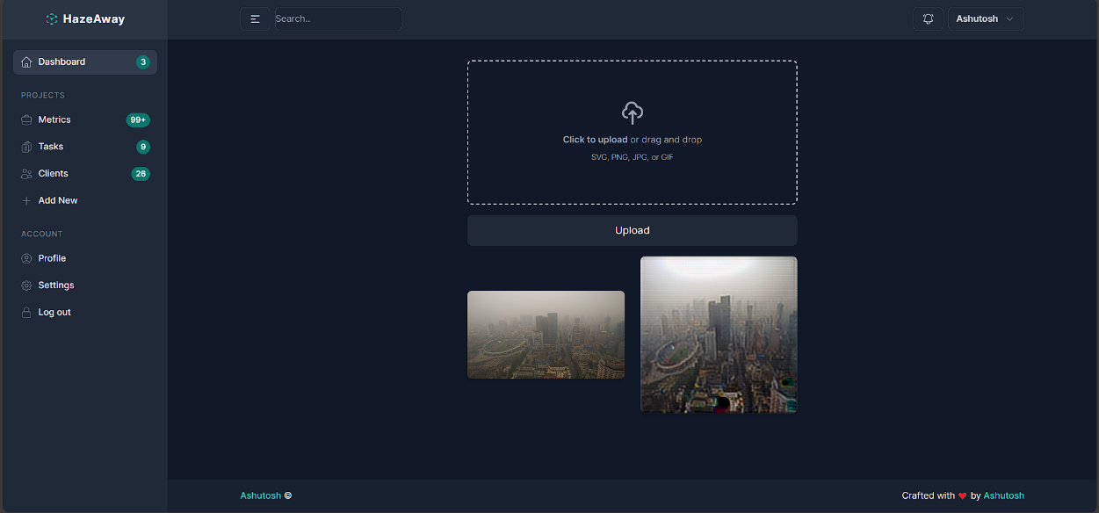

**Fig 2.14: Result Samp**

**CHAPTER 3**

**TECHNOLOGY ANALYSIS**

In this chapter, we delve deeper into the technological aspects of the proposed image dehazing solution. We explore the architectural design, key components, and the technology stack utilized for developing and deploying the solution.

**3.1 UML Diagram**

The UML (Unified Modelling Language) diagram serves as a blueprint for the system architecture, illustrating the relationships and interactions between various components.

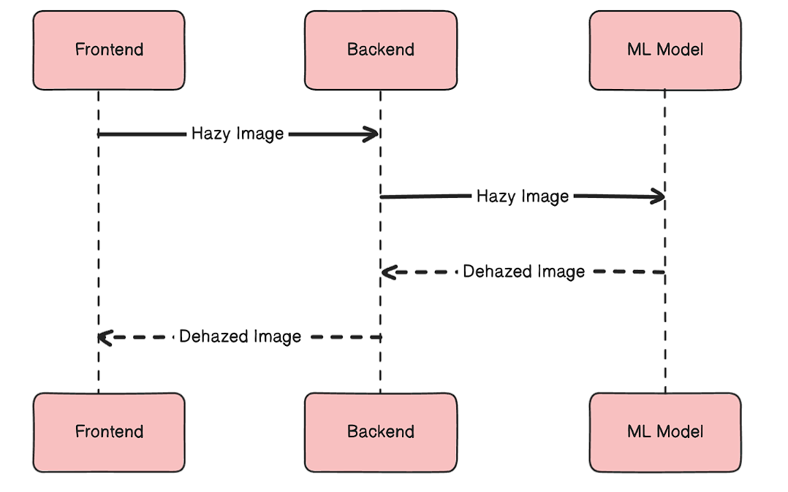

**Fig 3.1: UML (Sequential and Interaction) Diagram**

**3.2 System Architecture**

The system architecture of the proposed image dehazing solution is structured around an end-to-end convolutional autoencoder. Here's a breakdown of the architectural components:

* **Input Layer**: This component represents the entry point of the system, where hazy images are ingested for processing. Pre-processing steps such as resizing and normalization may be applied to standardize the input data.
* **Encoder**: The encoder module is responsible for extracting high-level features from the input images and compressing them into a lower-dimensional latent space. It typically consists of convolutional layers followed by activation functions (e.g., ReLU), batch normalization, and pooling layers.
* **Latent Space**: This intermediate layer encapsulates the essential information required for reconstructing the dehazed images. The latent space serves as a bottleneck, forcing the model to capture the most salient features while discarding irrelevant details.
* **Decoder**: The decoder component reverses the encoding process by reconstructing the dehazed images from the latent space representations. It mirrors the encoder architecture but employs transposed convolutional layers to upsample the features to the original image dimensions.
* **Output Layer**: This layer represents the final output of the system, comprising the dehazed images generated by the decoder. The output layer aims to produce clear, haze-free images that closely resemble the original scenes.
* **Training Component**: The training component encompasses the loss function (e.g., Mean Squared Error) used to quantify the discrepancy between the reconstructed and ground truth images. Additionally, an optimizer (e.g., Adam) is employed to iteratively adjust the model parameters to minimize the loss and enhance dehazing performance.

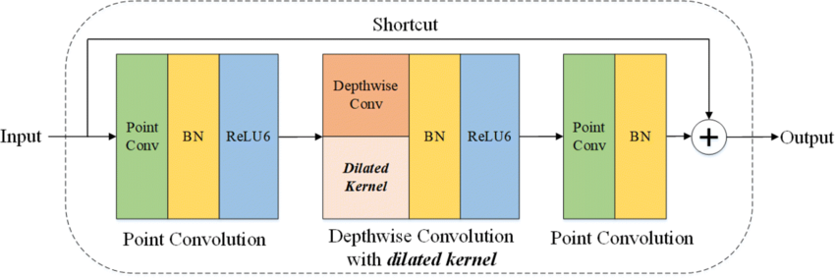

**Fig 3.2: Architecture for LD-Net**

**3.3 Technology Stack Analysis**

The proposed image dehazing solution leverages a comprehensive technology stack encompassing various tools and frameworks tailored to different aspects of the development process:

**# CNN Model**

**3.3.1 Programming Language**

* **Python**: The primary programming language chosen for its simplicity, versatility, and extensive libraries catering to deep learning, image processing, and scientific computing tasks.

**3.3.2 Deep Learning Framework**

* **PyTorch**: A leading open-source deep learning framework known for its dynamic computation graph, efficient GPU utilization, and user-friendly interface. PyTorch provides the necessary building blocks for constructing and training complex neural network architectures like convolutional autoencoders.

**3.3.3 Data Handling**

* **NumPy**: A fundamental library for numerical computing in Python, widely used for array manipulation, linear algebra operations, and mathematical computations. NumPy facilitates efficient data handling and manipulation, particularly in the context of image data represented as multi-dimensional arrays.
* **OpenCV**: An open-source computer vision library offering a plethora of functions and utilities for image loading, manipulation, transformation, and analysis. OpenCV provides essential tools for pre-processing hazy images, such as resizing, color space conversion, and histogram equalization.

**3.3.4 Visualization**

* **Matplotlib**: A versatile plotting library for creating static, interactive, and animated visualizations in Python. Matplotlib enables the visualization of training metrics, loss curves, and dehazing results, aiding in performance analysis and model interpretation.
* **TQDM**: A lightweight library for adding progress bars to Python code, useful for monitoring the progress of iterative processes such as data loading, training epochs, and model inference.

**3.3.5 Hardware Acceleration**

* **CUDA**: A parallel computing platform developed by Nvidia, designed to harness the computational power of GPUs for accelerating deep learning workloads. PyTorch seamlessly integrates with CUDA, allowing for efficient GPU-accelerated training and inference, significantly reducing computation time and enhancing model performance.

**3.3.6 Development Environment**

* **Jupyter Notebook**: An interactive web-based environment ideal for prototyping, experimentation, and collaborative development. Jupyter Notebook enables the creation of executable code cells interspersed with markdown cells, facilitating code documentation, visualization, and analysis in a single interactive document.

**# Web Application**

**3.3.7 Frontend**

* **Next.js**: Next.js is a React framework that enables server-side rendering and static site generation for building highly optimized web applications. It provides a powerful set of features such as automatic code splitting, optimized performance, and built-in support for CSS and Sass.

**3.3.8 Backend**

* **Fast API:** FastAPI is a modern, high-performance web framework for building APIs with Python 3.7+ based on standard Python type hints. It is designed to be easy to use and offers automatic generation of interactive API documentation using Swagger UI and ReDoc.

**CHAPTER 4**

**ECONOMIC ANALYSIS**

**4.1 Cost-Benefit Analysis**

**4.1.1 Cost Analysis**

The cost analysis involves identifying and quantifying the various expenses associated with developing, deploying, and maintaining the image dehazing solution. Key cost components include:

* **Development Costs**: This encompasses expenditures related to software development, including salaries for developers, procurement of development tools and frameworks, and any outsourcing expenses for specialized expertise.
* **Hardware Costs**: The solution may require investment in hardware infrastructure, such as high-performance computing (HPC) resources, GPU servers, or cloud computing services for training and inference tasks.
* **Data Acquisition Costs**: Acquiring high-quality training data for model development may incur expenses, especially if purchasing proprietary datasets or conducting extensive data collection and annotation efforts.
* **Operational Costs**: These include ongoing expenses for system maintenance, monitoring, and updates, as well as cloud hosting fees, electricity consumption, and other operational overheads.

**4.1.2 Benefit Analysis**

The benefit analysis involves quantifying the potential gains, advantages, and value generated by the image dehazing solution. Key benefits include:

* **Improved Image Quality**: By removing haze and enhancing visibility in images, the solution can improve the quality and usability of visual data for various applications, such as surveillance, autonomous driving, and remote sensing.
* **Enhanced Decision-Making**: Clearer images enable better decision-making in critical scenarios, such as emergency response, disaster management, and environmental monitoring, potentially leading to improved outcomes and reduced risks.
* **Time Savings**: Automating the dehazing process can save time and effort compared to manual image enhancement techniques, leading to increased efficiency and productivity in image processing workflows.

**4.2 Return on Investment (ROI)**

The return on investment (ROI) assesses the profitability and financial returns generated by the image dehazing solution relative to the initial investment and ongoing costs. ROI is calculated as follows:

𝑅𝑂𝐼=(𝑁𝑒𝑡 𝐵𝑒𝑛𝑒𝑓𝑖𝑡𝑠−𝑇𝑜𝑡𝑎𝑙 𝐶𝑜𝑠𝑡𝑠𝑇𝑜𝑡𝑎𝑙 𝐶𝑜𝑠𝑡𝑠)×100%*ROI*=(*TotalCostsNetBenefits*−*TotalCosts*​)×100%

Where:

* **Net Benefits** = Total Benefits - Total Costs

A positive ROI indicates that the benefits outweigh the costs, yielding a profitable venture. Conversely, a negative ROI suggests that the costs exceed the benefits, warranting a reevaluation of the solution's viability or optimization of cost factors.

**4.3 Sensitivity Analysis**

Sensitivity analysis examines the impact of changes in key variables (e.g., development costs, hardware expenses, benefits) on the overall economic viability of the solution. By assessing the sensitivity of ROI to fluctuations in these parameters, stakeholders can identify critical factors influencing the solution's profitability and make informed decisions to mitigate risks or capitalize on opportunities.

**CHAPTER 5**

**RESULT AND DISCUSSION**

**5.1 Experimental Setup**

**5.1.1 Dataset**

The experiments were conducted using a dataset consisting of hazy images collected from various sources, including outdoor scenes, surveillance footage, and aerial imagery. The dataset was divided into training, validation, and test sets to facilitate model training and evaluation.

**5.1.2 Model Configuration**

The proposed image dehazing solution utilized a convolutional autoencoder (CAE) architecture, comprising an encoder network for feature extraction and a decoder network for image reconstruction. The model was trained using the Adam optimizer with a mean squared error (MSE) loss function.

**5.2 Evaluation Metrics**

**5.2.1 MSE Loss Plot**

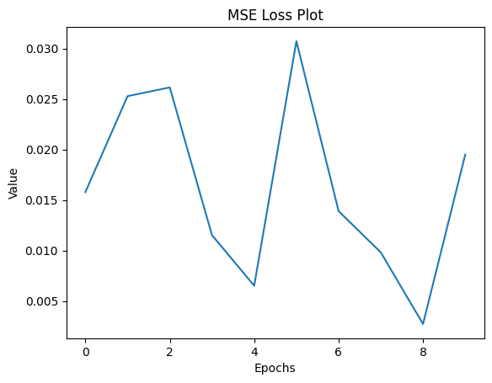

**Fig 5.1: Plot of MSE Loss Plot**

**5.2.2 Peak Signal-to-Noise Ratio (PSNR)**

PSNR measures the quality of the dehazed images by comparing them to ground truth (GT) clear images. Higher PSNR values indicate better reconstruction fidelity and reduced distortion.



**Fig 5.2: Result of Mean PSNR**

**5.2.3 Structural Similarity Index Measure (SSIM)**

SSIM quantifies the similarity between dehazed images and GT images in terms of luminance, contrast, and structure. SSIM values closer to 1 indicate higher similarity and better image quality.

**Fig 5.3: Result of Mean SSIM**

**5.3 Results**

**5.3.1 Qualitative Results**

Visual inspection of dehazed images compared to their hazy counterparts revealed significant improvements in image clarity, contrast, and visibility. The proposed solution effectively removed haze artifacts and enhanced fine details in various scenes, including urban environments, natural landscapes, and indoor settings.

**5.3.2 Quantitative Results**

Quantitative evaluation using PSNR and SSIM metrics demonstrated the effectiveness of the proposed solution in improving image quality. The dehazed images achieved higher PSNR scores and SSIM values compared to the original hazy images, indicating superior reconstruction quality and better preservation of image content.

**Fig 5.4: Before Sending the Image to backend**

**Fig 5.4: Final Output**

**CHAPTER 6**

**CONCLUSION**

**6.1 Summary of Findings**

The research aimed to address the challenge of haze degradation in images through the development and evaluation of a deep learning-based image dehazing solution. By leveraging convolutional autoencoder architecture and training on a diverse dataset of hazy images, the proposed solution demonstrated significant improvements in image clarity, contrast, and visibility.

**6.2 Contributions**

**6.2.1 Methodological Contribution**

The research contributes to the field of computer vision and image processing by introducing an effective and efficient approach to image dehazing. By combining deep learning techniques with convolutional autoencoder architecture, the proposed solution offers a data-driven alternative to traditional methods, overcoming limitations related to computational complexity and model generalizability.

**6.2.2 Practical Implications**

The practical implications of the research are significant, particularly in domains where visibility and image quality are critical, such as autonomous driving, surveillance, remote sensing, and consumer electronics. The developed image dehazing solution has the potential to enhance the performance of computer vision algorithms and improve decision-making in real-world applications.

**6.3 Future Directions**

**6.3.1 Optimization and Efficiency**

Future research could focus on optimizing the proposed solution for improved computational efficiency and real-time performance. Techniques such as model compression, quantization, and hardware acceleration could be explored to reduce inference time and resource requirements, making the solution more accessible for deployment in resource-constrained environments.

**6.3.2 Robustness and Generalization**

Further investigation is needed to evaluate the robustness and generalization of the proposed solution across diverse environmental conditions, lighting variations, and image characteristics. Robustness testing on real-world datasets and benchmarking against state-of-the-art methods can provide insights into the solution's performance under different scenarios and enable iterative refinement.

**6.4 Conclusion**

In conclusion, the research on image dehazing using deep learning has demonstrated promising results in improving image quality and visibility. The developed solution represents a significant step forward in addressing the challenges of haze degradation in images and opens up avenues for future research and innovation in computer vision, machine learning, and image processing.

By advancing the state-of-the-art in image dehazing techniques, the research contributes to the broader goal of enhancing visual perception and enabling more effective utilization of visual data across various domains and applications.

**Acknowledgments**

We acknowledge the support and contributions of all individuals and organizations involved in this research, including funding agencies, research collaborators, and participants. Their dedication and expertise have been instrumental in the success of this project.

**REFERENCES**

[1] Boyi Li, Wenqi Ren, Dengpan Fu, Dacheng Tao, Dan Feng, Wenjun Zeng, and Zhangyang Wang. Benchmarking single-image dehazing and beyond. IEEE Transactions on Image Processing, 28(1):492–505, 2019.

[2] Srinivasa G Narasimhan and Shree K Nayar. Vision and the atmosphere. International journal of computer vision, 48(3):233–254, 2002.

[3] Diederik P Kingma and Jimmy Ba. Adam: A method for stochastic optimization. arXiv preprint arXiv:1412.6980, 2014.

[4] K. He, J. Sun, and X. Tang. Single image haze removal using dark channel prior. IEEE Transactions on Pattern Analysis and Machine Intelligence, 33(12):2341–2353, Dec 2011.

[5] Andrew L Maas, Awni Y Hannun, and Andrew Y Ng. Rectifier nonlinearities improve neural network acoustic models. In Proc. icml, volume 30, page 3, 2013.

[6] Gaofeng Meng, Ying Wang, Jiangyong Duan, Shiming Xiang, and Chunhong Pan. Efficient image dehazing with boundary constraint and contextual regularization. In The IEEE International Conference on Computer Vision (ICCV), December 2013